Vegetable Trials of the Q2 Energy Spa
Tomato Trial
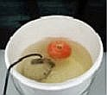
Charging tomato
All fruit purchased at the same time from the same shop. Fruit was treated the same except for the charging of one group.
Day 1
Charged Fruit
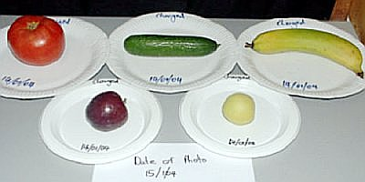
Uncharged Fruit
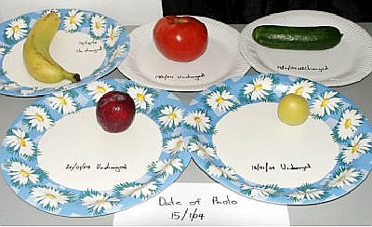
Day 4 - First Signs Of Damage
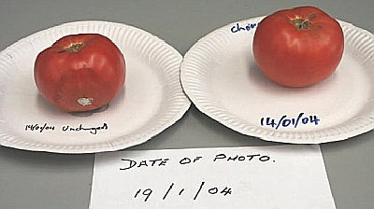

Day 8
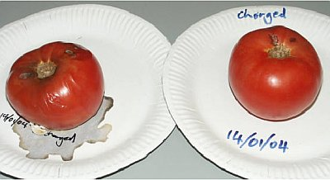
Day 12
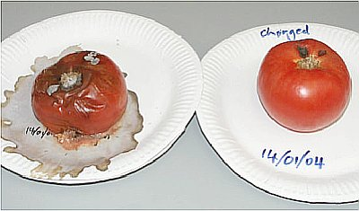
Day 20
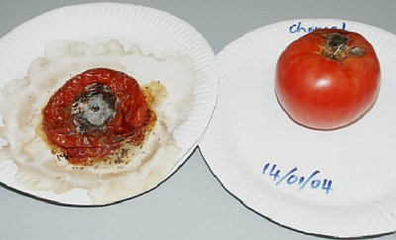

Day 25
Charged fruit inspected
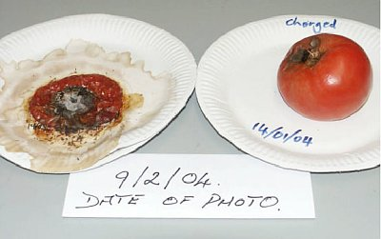
Sprouting seeds were found inside the charged tomato.
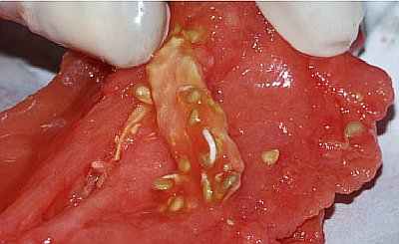

Cucumber Trial
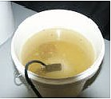
Charging cucumber
All fruit purchased at the same time from the same shop. Fruit was treated the same except for the charging of one group.

Day 1
Charged Fruit
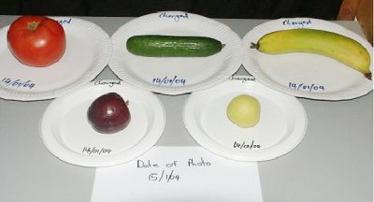
Uncharged Fruit
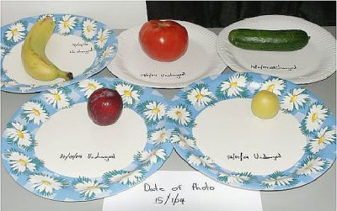
Day 5
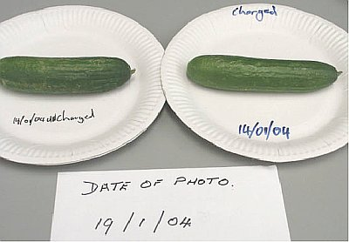
Day 12
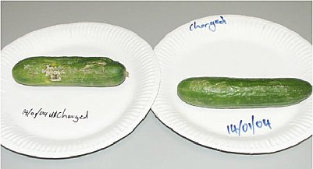

Day 19
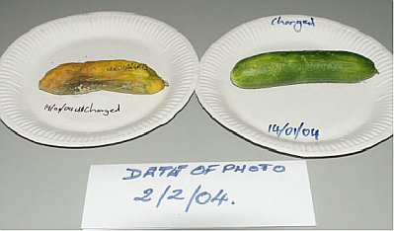
Day 21
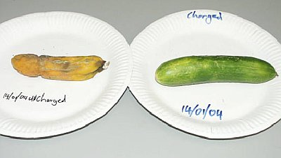
Day 26
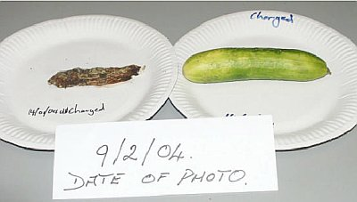

Charged cucumber was cut open and found to be still quite firm and edible.


