The 16 Different Electrode placements as a way to treat a sample of water for 16 different outcomes.

In the 5 Tube Cell design, there are 2 ways to construct this.
As a 2 Way Cell and as a 4 Way Cell.

The 2 Way Cell
The 2 Way Cell was what was published by Alex in his Experimenters Guide. This is the design most Experimenters copied. It has the Inner Tube protruding out the bottom of the Cell for a Negative Electrode placement with the Positive electrode being at the top of the outside Container or Tube.

There are only 2 Ways to connect this Cell correctly. Any other way does not give a Unified Field, meaning there is no Generation of an Infinite Number of Rotating Magnetic Fields from the 2 Way Flow of Electricity that creates the Figure 8’s or Infinity Loops. Each ‘Tube’ becomes ‘magnetic’ and has about its ‘tube’ an Iron Filings Pattern. All 5 Tubes become a Unified Iron Filings pattern. This Field Effect is imparted to make the Water Magnetic with its own Iron Filings Field Lines of Force.

It’s a 2 Way Cell because the electrodes can be reversed for 2 distinct outcomes as seen Here. The protrusion out the bottom does not give a Unified Field if the electrodes are connected at the top.

This Cell design and the North Pole Negative or Negative/Negative electrode placement is the configuration that runs cars by implosive forces of the Winds Imploding inside the cylinder if its ‘tapped’ to be a Stage 3 Elemental Wind Charge Up.

To get a Stage One Cell, one connects the Negative electrode first and then connects the positive electrode and let it bubble. Stage 1 ‘acts’ upon the ‘dissolved’ solids in the water which is the First Elemental State of Matter.

To get a Stage 2 Cell, one connects the Negative lead First and then taps the positive electrode and then leaves the Positive electrode connected on the second contact. This configuration or Sequence of Charge Up of activation acts upon the Liquid or Waters Tetrahedron Crystal Structure.

To get a Stage 3 Cell, connect the Negative lead first and tap the positive lead to a tube twice and leave it on the 3rd time. This activates or imparts the FREQUENCY to make the Winds Implode or explode depending upon if you are doing an implosion demo or an explosion demo. Note in the Demo above the implosion/explosion will still be apparent but if its implosion of Wind that’s required to be Manifest in your experiments, this is the ultimate Implosion connection.

To get a Stage 4 Cell, connect the Negative first and then tap the Pos 3 times and leave it on the forth. This activates the Element Fire to be manifest. Electricity is Fire. Electricity may pierce the body when lighting the bubbles and cut the Experimenter like a stab wound as it jumps out of the Cell and bounces around the shed like a bolt of Lightning. You have been warned.

This 2 Way Cell then has 8 outcomes with a single batch of water.

It is Possible to drain Life Force from spectators and death may result if one plays with a Positive/Positive Cell in the wrong way. Joe only makes Neg/Neg devices.

The 4 Way Cell

The 4 Way Cell is identical to the 2 Way Cell except it DOES NOT have the protrusion of the inner tube out the bottom. All 4 inner tubes are the same length and are contained within the outside Tube. The amount of water under the Tubes should equal the amount of water over the top of the tubes.

Lets call the Inner tube, Tube 1, and the outer tube, Tube 5, with corresponding 2, 3 and 4 as the other 3 tubes.

Tubes 1,3 and 5 are the ‘electrode placement Tubes’ in a 4 Way Cell and all are connected at the top. This gives the ‘same’ configuration as the 2 Way Cell using the inner and outer Tubes for 8 outcomes.

When Tubes 3 and 5 are the Tubes to have electrodes attached we have another FIELD EFFECT that’s different to the 1 and 5 placement and this sequence also has 8 distinct outcomes for a total of 16 with the 4 Way Cell when taking each placement through the 4 Stages.

The FOUR distinct Field Effects are North Pole Negative, South Pole Positive and North Pole Positive and South Pole Negative. We have this Polarity as a Field Effect on our Body as displayed as the Polarity of our Hands. This is important when using a car battery to CHARGE UP™ the Human body Cell and checking to see if our Di-Pole Brain/Battery is fully Charged Up. Once charged and balanced we can then induce Ozone.

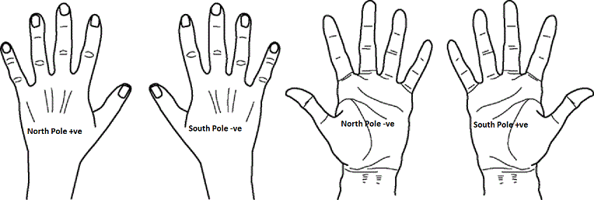

We can duplicate this Electrical Polarity in a battery by making a Double Negative Battery. We duplicate this with Magnets by placing a washer between 2 North Poles of a Magnet. (mooker is an over educated too far in the other direction jerk)

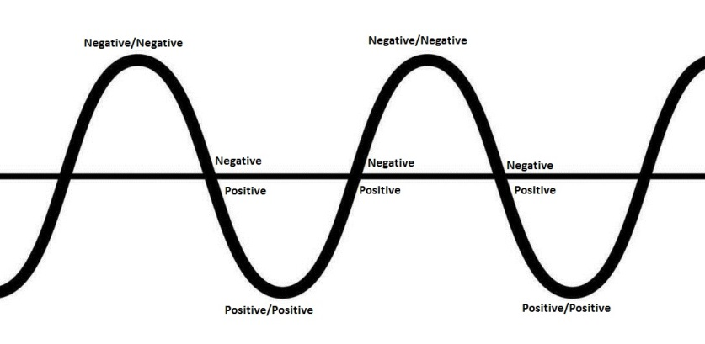
As the Wave ‘progresses’ it goes through the “line” twice and has a High and a Low. The 4 Phases of Magnetism or Electricity as it progresses goes from Neg/Neg, Neg/Pos, Pos/Pos and Pos/Neg. These are the Dominant Field Effects. In the Human reproductive system, the Woman’s egg has a Positive Positive Charge. Her Cervix is Positive/Negative. The Sperm is Neg/Neg and a mans urethra is Negative/Positive. The sperms TAIL is only a propeller. It’s the Magnetic Attractive Forces that sees the sperm swim towards the egg obeying the laws of Magnetic Attraction. Once Positive meets Neg, there is no more ‘attraction’ and the sperm all swim randomly now.

Our hands, human reproductive mechanisms and the operation of the TubeCell, everything has these 4 Phases as ALL MATTER on Earth is Formatted. The 4 Elemental States of Matter. The Rotating Magnetic Fields create an Attachment Point to the Aether or the 5th Element ‘Quintessence’ and without this Mechanism there is NO AETHERIC ENERGY forthcoming. Period.

As you can see, this Unified Field can only be Unified if each Tube is Dowsed for Polarity and the North Poles of each Tube are at the Top. One is essentially Lining Up Magnets.

You did ask for the 16 electrode placements. This is what they mean and these 4 Phases of Magnetism is what JoeCells are ALL about. In Joe’s own words, North Pole Negative Fields are where the Magic comes from. Man ONLY plays with Hot Fusion or Explosive Forces. North Pole Negative Fields are Cold Fusion Forces. Our Indoctrination system has everyone educated too far in the Thermo-Dynamics direction. Everything is measured in BTU’s. Everything creates Heat. Joe’s cars ran as cold as the Ice that falls from the sky as the Winds Implode to make it rain.

This discourse is a double edged sword. Don’t try to make a cold fusion stage 4 TubeCell before you know what you are doing. Joe did 1000’s of experiments to understand the 4 Phases. Stick to Phase or Stage 1 for Months.

North Pole Forces Clean Waters. South Pole Forces ‘dirties’ waters into oil or coal. Better to understand a 2 Way Cell first. At this time its impossible to understand what the intermediate Phases of the 4 Way Cell actually do. This is Advanced Alchemy as it took me decades to understand it all. The REAL Magic lies in the ConeCell and its still being built.

