Bio Electric Charge and the Treatment of Infertility in Equine Breeding
By Lynn Eykamp Aetheric Physicist

Background;
Lynn Eykamp was a former Director of Q-Tech Laboratories, a Research and Development company which specialised in newer concepts of Energetic Medicine. Lynn built and developed the Q2 Energy Spa “Orb” from its beginnings in 1996 on his farm to a worldwide marketed product on the cutting edge of Energy Medicine. Along with another company, the Aqua Chi, (an identical and off shoot product) it is estimated some 20,000 of these units have been used by individuals, Chiropractors and alternate Health providers in the last 17 years.
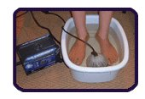
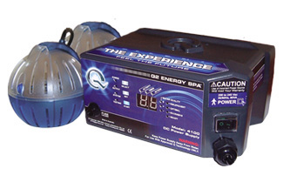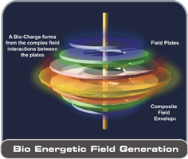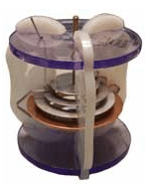
The device Q2 Energy Spa Orb The ring construction of the Orb The Aqua Chi The most practical way to use the Orb

The Concept;
The application of DC electricity to an “antenna array” or Orb immersed in a tub of water to increase the Bio Energy of life forms within the water and in this particular case infertile mares. The Orb develops a Bio Electric Charge within the tub of water which is absorbed by the mare. This Bio Charge is to enhance the mare’s immune system and cellular functions. In the years of 1997 to 2005 many positive results were obtained in Alternative Healing centres and in some individual cases, with infertility, as the Orb was trialled by 10,000’s of people worldwide.
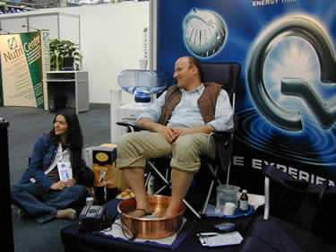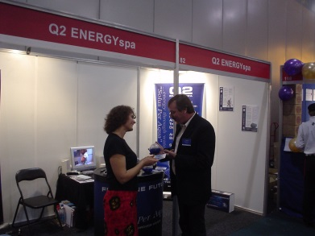
Two of the many expositions promoting the Orb technology throughout the world

The Application;
The use of the Orb requires the feet or hands or the whole body to be immersed in a tub of water. Treatment is for 30 minutes every 2 days and involves DC electricity to be applied to the Orb during treatment. A Horse Spa was purchased for this application.
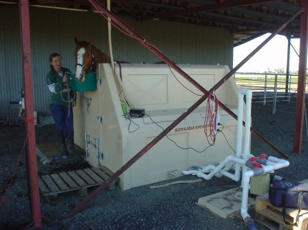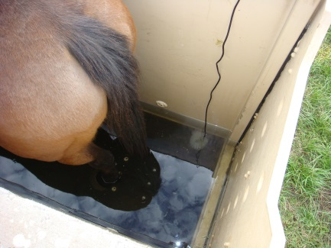
Figure 1UpSized
The

The Initial Concept;
In about April 2004, it was decided to use the Orb technology for the ‘performance enhancing’ attributes that theoretically can be obtained by increasing of the Bio Charge of a race horse. Not knowing much about the breeding of or the thoroughbred racing industry, Lynn, his son Nicholas and Ian Symons a local trainer purchased a colt from the Scone Yearling sales for the price of $8,500 and named it Upsized. The project was to follow the guidelines that Lynn had learnt about Bio Charge Enhancement from his Directorship at Q Tech Laboratories.
Upsized was to be trained and Orb bathed in his first preparation leading up to his fist race. Instructions were given to give UpSized another Foot Bath with a “specialised” version of the Orb, the Silver Neutral on the morning of the race. Upsized easily won the Tattersalls Gourmet Club Plate at Randwick on Sat 26th Oct 2004, his maiden race.
It was unfortunate that the Trainer thought it was due to his training rather than the Orb and no further Orb Baths were given to Upsized. The pin was pulled on Orb baths and horse trainers.

The Next Step;
With disagreement in training procedures, and much knowledge gained from this interaction of the racing industry, Lynn decided to breed thoroughbreds rather than buy a yearling so as to “breed in” this enhanced performance. With funds being short, the place to start was well bred mares with infertility problems as the trial from people using the Orb indicated infertility was reversed in females. Some statistics show infertility in the thoroughbred industry is as high as 15% so there must be some well-bred mares amongst their numbers.

The Six Mares;
Over the course of the next few years starting with Eleebana in Jan 2005, 6 mares with infertility issues were purchased.
Eleebana, Dinwit, Foottapper, Astonishment, Transparent Lass and Asia.

Eleebana came from Ballarat Vic and was purchased at the end of the breeding season with another miss. The Stud Master there said it was due to her egg follicle not releasing and thus missing. We placed Eleebana in the paddock til July and commenced Orb Baths for 2 months when she fell in Foal on her first service in early Sept. Eleebana was bathed for her next service the following season but not since and has had no issues with fertility since.

Astonishment was purchased at a thoroughbred sale in 2006. After a month of baths she fell in foal on the second service to E Dubai. Her history was one foal in 4 years with misses in the preceding 2 years. In 2007 the following year she was sold as a 3 in one package.

Transparent Lass was a little bit more difficult and she was given Orb baths for a month as well as other natural regimes. The previous owner did not believe she was pregnant and even after phone calls, he drove from Brisbane to Murrurundi 9 hrs, to personally view the foal nursing Transparent Lass. She ruptured herself in a subsequent birth and even though no baths were needed to get her in foal, the injury left her permanently infertile.

Dinwit was purchased for 500 from a Stud in Tamworth late in the breeding season as they had given up after 5 unsuccessful breeding seasons. We gave Dinwit 6 baths before she came into season and she fell in foal first service on the 22nd Nov 2007.

Foot Tapper was purchased for 500 at a thoroughbred sale. She was given only 5 baths and fell in foal first service to Octagonal. Unfortunately the Foal ran into a tree and broke his neck. Foot Tapper’s history was 4 unsuccessful breeding seasons prior to our treatments. We sold the mare the following season.

It must be noted that NO form of veterinary procedures or drugs of any kind were administered to the above 5 horses. We feel that the absence of traditional Veterinary procedures coupled with a natural diet of no manufactured supplements or feeds was best with the Energy baths in order to prove that the baths constituted the major influence in treating their infertility.

The mare Asia was the last mare purchased as we felt 5 from 5 was worth the investment.
We were informed from the owner’s contacts that her problem was “mosaic” genes. No expense was spared by Jim Flemming’s Stud to get Asia in foal.

We bathed Asia for many months prior to her first Service. We understood that getting Asia in foal wasn’t the problem it was her keeping it. She absorbed the embryo. Our Bio Energetic understanding indicated that her ‘problem’ was not that she had not enough Bio Charge, but that she had TOO much of a positive charge, so the baths actually weren’t helping. She required a ‘balancing technique’ whereby direct DC stimuli was to be applied to her bodies ‘meridian energy lines’.

It should be understood that the body can take months or even a year or two for the effects of prolonged Bio Charge enhancement to be noticed by the user or subject. After two years of treating Asia, coupled with funds for the project being part of a property settlement, the whole project of breeding mares was terminated. She fell in Foal for the new owners.

How the Bio Energy of the Orb Works;
This this theoretical biology. Part of the mare breeding program was to do a kind of clinical trial for infertility but using horses instead of humans.

The theory states, in part, that mammals are more a Bio-Electrical energy user rather than just a nutrient consumer and that bodily functions are based more upon the differing bio charges of bodily fluids that individually are more of a magnetic nature in their interaction.

So in the case of fertility, the magnetic attraction between the sperm and the egg has to be of a certain magnetic attraction strength for conception to take place. And as exemplified in the case of Eleebana, her Bio charge wasn’t sufficiently strong enough for the body to release the egg. Generally, infertility is because the egg isn’t sufficiently charged positively for the negatively charged sperm to be attracted to the egg.

The overall increase of the Bio Charge of the mare being enhanced by the Orb’s action of converting artificially created magnetic energy being converted to Direct Current and “charging” the water so the mare absorbs this charge energy and all functions of the body can now have the correct charge and if the infertility is caused by lack of bio charge or ‘life force energy’ then the problem should be fixed with just a couple baths as happened in the above mares.

This theoretical Bio Charge enhancing the horse’s natural functions could mean that when used in a training program, muscle building and stamina are increased. More on this aspect should be done.

Attachments

University of Tennessee Tests Using
Aqua Chi/Total Charge

Cellular Energy Transfer Science and L929 Cells
University of Tennessee Health Science Center
Department of Immunology, Microbiology & Biochemistry
Marcy C. Purnell RN,MSN, FNP-C
Michael A. Whitt, PhD

HEALTHY CELLS

Normal Cell Growth Increased
Using the Total Charge Super Body Charger Treatment in an in vitro cell study, cell growth is increased to more than double by day three, demonstrating how effective the treatment can be.

Healthier Cells
Increased Cell Division
Faster Recovery Time
Increased Overall Health
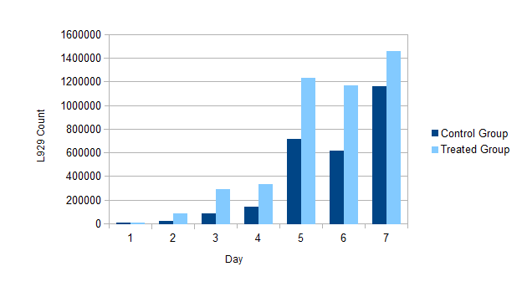
University of Tennessee Tests Using
Aqua Chi/Total Charge

Cellular EnergyTransfer Science and B16 Cancer Cells
University of Tennessee Health Science Center
Department of Immunology, Microbiology & Biochemistry
Marcy C. Purnell RN,MSN, FNP-C
Michael A. Whitt, PhD

Could This Be A Potential New Cancer Treatment?
CANCER CELL GROWTH
Miraculous results Using the Total Charge Super Body Charger Treatment in an in vitro cell study.
Cancer cell growth is inhibited significantly, demonstrating how effective the treatment could be.

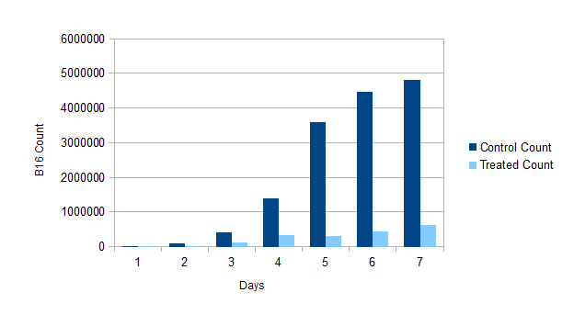

Look What Aqua Chi/Total Charge Did For These Plants.
Strawberries Grown With Untreated Water. Strawberries Grown Using Total Charge Body Super Charger Treatment
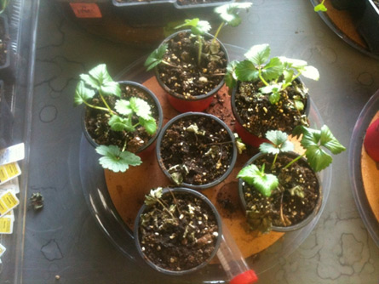 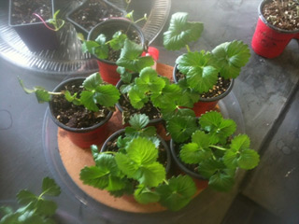
Healthier Plants, Increased Growth
What Will Total Charge Do For You?

Help You Get Fit Faster Increase Your Endurance Speed Healing
Help Relieve Your Sore Muscles Increase Your Muscle Strength Manage Pain
Burn Your Fat Faster Improve Your Cardiovascular Support Faster Recovery
To Ask Questions Or To Book An Appointment
Aleesha K. Ashlie 704-995-5337
Tony Williams 0428 932 663
Ascot Heath P/L
Box 32 Murrurundi 2338
suewilliams08@bigpond.com 0427 054 618

