Power supplies.

Do I understand correctly that the "Aqua Chi Module-Array" can be powered by direct (not pulsating) current 30V 3A ?
So that I dont need the original power module?

To clarify. Any AC to DC power supply will have a ‘ripple’ in the DC output. Sometimes referred to as ‘noise’. This is because Diodes, that do the rectification from AC to DC are tiny ‘batteries’ and depending upon their material construction (semi conductors) the clarity or noise or the still evident ripple or AC pulsed current effect will always be evident. This will cause a Pulsed Magnetic Field, albeit miniscule, but nevertheless, the Field will Pulse at 50 or 60 Hertz. This cannot be avoided and the Water Module has more ‘pathogen actions’ with this pulsed effect. As stated, if we had 113 Hertz AC to DC this ripple or pulsed Field effect would be more beneficial. But all we have is Mains AC to work with. Unless we use up to 4 car batteries to power the water module but this is not for beginners.

So all Rectified DC can be described as Pulsed Magnetic Field Generation that the Module imparts to the Water Field. AC is actually Pulsed DC where the DC current starts and stops 50 times a second.

To build your own Bath Device, you buy the module and cables from Aqua Chi suppliers and we find an alternate AC to DC power source than the US$1000 they want for a factory power supply.

Attached is a picture of the ‘Peter Martin’ power supply. This is the power supply that we used to build the first 100 units for market back in 1997/8. We went to making our own and its only difference is we have a current draw or Activity Meter as seen in the black box model used for the next 300 units before we had one specially made in Melbourne in 2000.

The original Peter Martin power supply was “hot wired” so to speak, meaning the primary and secondary coils were all in the same configuration. It burnt out easily if the water had too much electrical conductivity. The specially made one had 3 secondary windings for 3 levels of output to accommodate the inconsistency of waters used. These 3 secondary windings were outside the Primary Windings so less heat generation and almost none ever failed.

The Peter Martin power supply was the one all the trials were done with. In my opinion it was the most effective for biological usage. The black box model was about the same. But I do believe the special power supply had less UMPH but enough all the same. I searched the web and found all the Alternate health practitioners in Oz that used Rife machines (which are ‘illegal’) as they had ‘open minds’ and were open to new technology. So I have quite some background in the 2 technologies from many practitioners and their ‘results’. I gave 10 of these to Clinics for trials on their customers where we obtained 100’s of testimonials.

I have stated that ‘switching’ power supplies, ones that will work on both 120 and 240 and many Lab or Bench power supplies are the least preferred. These power supplies have a whole circuit board of components as verses what you see in the peter martin supply. Water takes on the Memory of everything it contacts. Electricity is the 4th Phase of Water as in the 4th Elemental State or Fire. So as the vibrations travel around the circuit board, it picks up the ‘elemental’ frequencies of the components and these ‘extra’ frequencies are now part of the Field Generated in the water. They are in the ‘micro wave’ bands.

Now if you have been given 3 months to get your affairs in order, Switching Power supplies and micro wave contamination is the least of your worries and I DO recommend they can be used to Stop the terminal condition. See pics of such power supplies.

One can order from china Linear Power supplies like also shown in pics that are non switching and set for the Voltage of your country. Expect to spend 300. But you have to adapt the Aqua Chi cables to the socket.

The following examples are NOT recommendations but Guidelines for replacement power supplies. (I have even used cheap laptop power supplies of 18vdc and 3 amps on life forms)

This one.
https://www.ebay.com/itm/365807879706?_skw=24v+linear+power+supply+120w&itmmeta=01KDRT7CXZ1B4C08FTAWY2XYTZ&hash=item552bd9461a:g:UnUAAOSwpOxnrvD3&itmprp=enc%3AAQAKAAABAFkggFvd1GGDu0w3yXCmi1cWhUbz6J7ndJQTh%2FlL6Kn9ZMq%2FYGxy7xBsJQ5%2Fbyhdsi7FCQZYgTGboDV89tKKJFZvq%2Bw1hzcM4Evef1FMsXkGMBiC5eGeIKIfrCss8q1f8drT7PmGtayhrWAgNNDIU18dXep%2FpNs9Wil44xXcGmch%2FPVmog9CZPJJrBLnalUMpk%2BM7gng%2BO2SrNsex%2BCUpGLMZbC1KXzsAUpDzlhNTDeGXi7cXb9HwC0hUqSpt564NlFCpuWVrs7lZE3nq76VRsJoTnJwvNGQrRO9Jgub3PBz9Cmh8GqVV1htNTbXtNyMSyOhn1D1kO8xUpjpSki0tbw%3D%7Ctkp%3ABk9SR6LPnZruZg

or
https://www.ebay.com/itm/205593383954?_skw=24v+linear+power+supply+120w&itmmeta=01KDRT7CXYR4JJV5747EWKH4VZ&hash=item2fde521412:g:EMcAAeSwECxoZShq&itmprp=enc%3AAQAKAAAA4FkggFvd1GGDu0w3yXCmi1fAjQ1puQbTHDh92zeoGg7MQp7ODPby1t6v%2F5SJ2THTTaamcN%2ByUOsD2vzubug3oyENGa41kKAVi44YBAEqMU38O%2FFgx%2BmrY91pY45Em6DPIKFmCii8y30%2FpSGGvBs7lpsJljfyyUUniWP4q2CVopsY2NpU777w8dRdfcStAaY3cCae9e49xkLIZM3f3A%2B15KW6SpO5GHqSQFLt--OWW%2BaegDzTFXkD%2FFRemMKrgraSaD0DNlH3F56jXdXbxxqsDGiJ5qbiNX%2FHt8Hd%2Fd7SiG5J%7Ctkp%3ABk9SR6LPnZruZg

The above two can be custom made to 24vDC output and would be my first choice of generic power supplies to power the water module. I already have similar.

Terminal biologics can use the following.
https://www.ebay.com.au/itm/167744816663?_skw=lab+power+supplioes&itmmeta=01KDRTGA6DWM589H2VTMVQRNEF&hash=item270e5ec617:g:0w4AAOSw4dRkwiQX&itmprp=enc%3AAQAKAAAA0FkggFvd1GGDu0w3yXCmi1dqOn6Dx63r1SGKRxSW%2BjaPL2mNwY57eq%2FGUxim22blOPqVGLrMF2mxtJUVoYaqAO7FoLHiZn%2BZ08zv71fM%2FMFM%2BgafRzs0Tm4EKuUJ%2FzrRNVkmkrfJm6twoVTo7WtdAuJ88cnIyH14BEPH6bAQ8%2FcT9MZczPE5bPNwK96zDxMP%2B6yc0MamV1bJxyAKTuwjkEP6Gv7YjFAVwnjdA%2FF11Wglt%2FnNzoJ3V8g9eJami2mtVku6OepsjEuIj9yuFP7ZKT4%3D%7Ctkp%3ABk9SR6CkwZruZg

https://www.ebay.com.au/itm/389432769989?_skw=lab+power+supplioes&itmmeta=01KDRTGA6DZBNPB8HX376XHHX1&hash=item5aac007dc5:g:R28AAeSwma5pU32u&itmprp=enc%3AAQAKAAAA8FkggFvd1GGDu0w3yXCmi1d4PVllyXlkTf8Jh9Pw6xYyLeJ9VdZdDVjy99zDr4tq%2FsNxT6cWFyABuXTM6ij36dNKQqggPfO7crbgr8xxfphMtewB6wVWGpt241l9PtgsecxpHKWZ14fadkFuGgj4Gamyyu5BO6hFQnZiklmAcaGE7VQw2npAOPa4DIV%2FrjdSNlIYH1uVHnGlHhC4TmVIBWoFJuw2w4UFrqCYVMHyZPHVjVZz6PYwU%2FDk7bMXKa376K8wPZBLmWwBCmZFyq7QjJiwQFqM%2FvUSfIVN33Pl3KMTCViw4eMbJ1K4PWpo4KrFIQ%3D%3D%7Ctkp%3ABk9SR6CkwZruZg

the expensive model

https://www.ebay.com/itm/306528768603?_skw=24v+linear+power+supply&itmmeta=01KDRSQT0Q81ABEK2Y5WNPCWZ4&hash=item475e89d25b:g:TPMAAeSwXEVo3vr7&itmprp=enc%3AAQAKAAAA0FkggFvd1GGDu0w3yXCmi1el25LVrS%2BGBy4G8C3cpmu%2F8KH%2B%2FHrmn8jgshCpjv0f93h3hWqg7W8v0Nqk4T98OhSixEtghv6mbGKtmLRgazxZR%2BD5wB4v027S3nwwtaXXO9eAJhcvqsTctPBDHU8GQYCvD7fz0yP%2B2f3oAF3Yb0OBMfJu7LNKVw0bo6ujGl10%2FdtrSDYEGQ%2BIan269O2K9z%2BFsrH6aS1XtIGYK%2FHjZZLD7myDdNTIbo8b88wtzpnN77Z%2F4j2lkdNwWK2sjlMgFpk%3D%7Ctkp%3ABk9SR8qg35nuZg

These are the original power supplies from 1997 to 2000.
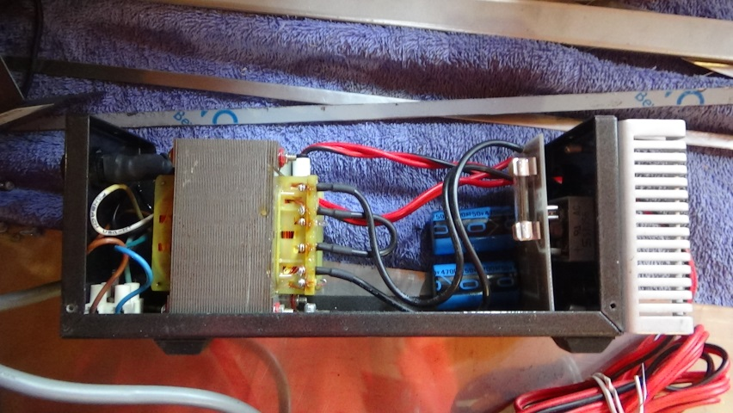

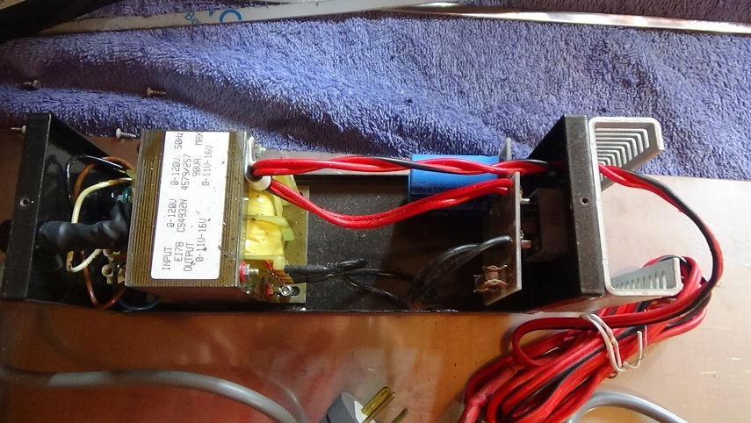

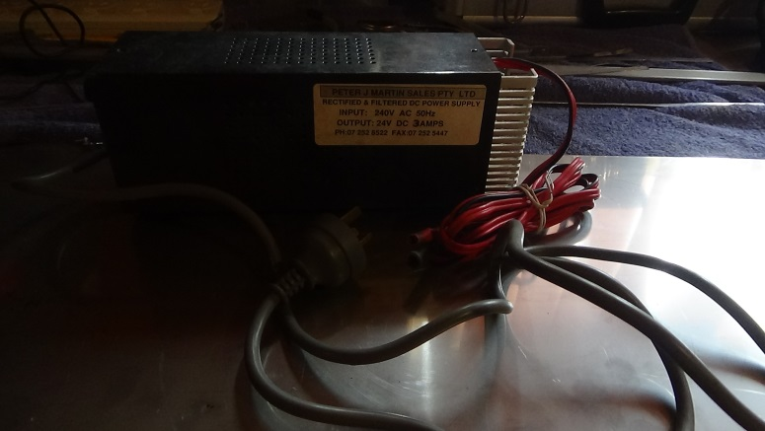

This is the Chinese Linear Power supply I had custom made 240VAC to 24VDV with 5 amps output.

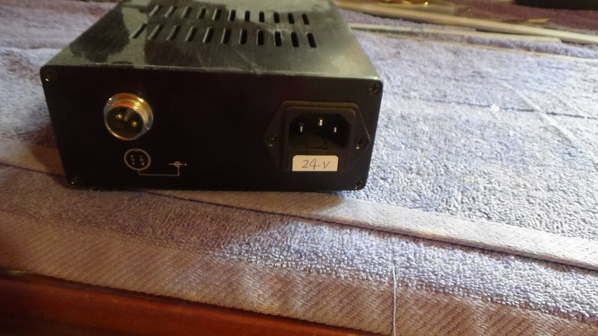

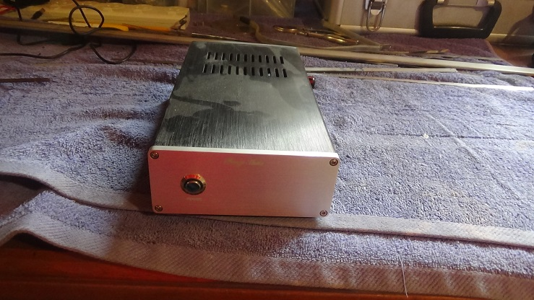

More pics of the older Q Tech power supplies


